2017-2018 ALA CD#40_61518_ACT
EBD # 5.4 --2017-2018
2018 ALA Annual Conference
Report of the ALA Special Task Force on Sustainability
Executive Summary
The ALA Special Task Force on Sustainability was formed in 2017 by the ALA Executive Board in response to the ALA Resolution on the Importance of Sustainable Libraries and the need to spark the development of actionable initiatives to further this work. The Special Task Force membership includes individuals with a variety of specialties, academic, public, and rural, as well as library architecture. The task force had an inaugural meeting in October 2017 and began work thereafter with bi-weekly meetings. A draft report was presented to the Executive Board at the ALA Midwinter Meeting in 2018 with the important highlight of the adoption of the “triple bottom line” framework of sustainability to guide our work: To be truly sustainable, an organization or community must embody practices that are threefold: environmentally sound, economically feasible, and socially equitable. In preparation for the final report, the task force reached out to the ALA membership: four online forums were held with a cumulative attendance of 80 individuals and a Perceptions Survey was administered, garnering the participation of more than 600 ALA members who offered more than 190 responses to a request for examples of libraries that provide leadership and serve as a model for sustainability for those they serve. This white paper summarizes the work of the task force, feedback from the membership, and provides direction for future implementation and innovation within our association and the profession all with an eye towards the creation of sustainable libraries.
Introduction
The State of America’s Libraries Report 2018 has identified sustainability as a major national trend. To introduce this trend in the report, a definition of “sustainable thinking” is provided: “Sustainable thinking refers to the alignment of a library’s core values and resources, including staff time and energy, facilities, collections, and technology—with the local and global community’s right to endure, bounce back from disruption, and thrive by bringing new and energetic life to fruition through choices made in all areas of library operations and outreach.”

This mindset of “sustainable thinking” helps us focus on the fact that we’re all in this together.

From our mission as members of an association devoted to “providing leadership for the development, promotion and improvement of library and information services and the profession of librarianship in order to enhance learning and ensure access to information for all” to our service in our individual institutions to our civic and personal lives - we are all working to make the world a better place. Through ALA we find others pulling in the same direction, using library service as a platform to do good in the world.

Before us lies, perhaps, one of the greatest periods of opportunity in our history as an association. The bid to improve ALA’s organizational effectiveness to create a modern association for a modern profession, the work of the Task Force on Equity, Diversity and Inclusion and, now, our focus on the topic of sustainability have the potential to create a cohesive rallying point from which current and future association members - across all disciplines and library types - will more fully connect with ALA’s Core Values, key action areas and strategic directions.

Key to this new chapter in the association’s history will be the executive board’s ability to inspire the membership: to clearly convey why we do what we do, to believe so fully in the potential of our association that we walk the walk, operating our association in a manner that aligns with our core values so that our efforts to lead the profession are genuine and authentic. When more people understand why we do what we do and believe in what we are doing and how we are doing it the bigger the impact we can have.

This focus on community sustainability is at the core of the work our association needs to do. When considering the urgent environmental threats – air and water quality, food insecurity, depletion of natural resources, rising sea levels, more frequent severe weather and the multitude of economic, political, technological and social disruptions that are evolving concurrently with these life-threatening developments, what the world needs now is more empathy, respect and understanding so that people can pull together to find shared solutions to the issues that affect us all. Libraries are very well positioned to play an increasingly important role in helping communities thrive in the face of the disruptions our world is faced with. We cannot address just one facet of our community, we must consider a community as a whole system.
The ALA Executive Board must take a bold position to lead us as an association, and as a profession, to support libraries that do critical work to model a way forward, convene and connect neighbors and build community resilience. Results of the Task Force’s Perceptions Survey indicate that a majority of ALA members do not currently view the ALA as a model for sustainable operational practices, meaning that its operational practices do not exemplify a commitment to environmental stewardship or economic feasibility and that the work on social equity has just begun. This reinforces the Executive Board’s thinking that we must lead “from the inside out,” we must lead with our everyday choices in order to inspire our profession and our communities.
The work ahead cannot be isolated from the development of the association’s future, what is necessary is a mindset or paradigm shift. Sustainability is a lens through which all decisions should be analyzed as it provides the guidance we need to be true to our core values.

Background
At the 2015 ALA Annual Conference in San Francisco, California ALA Council passed their “Resolution on the Importance of Sustainable Libraries.” The resolution notes that libraries play an important and unique role in wider community communications about resilience, climate change and a sustainable future. Libraries that demonstrate good stewardship of the resources entrusted to them can build community support that leads to sustainable funding as their actions will be more fully aligned with community aspirations.
The resolution goes on to encourage the American Library Association, its membership, library schools/iSchools and state associations to be proactive in their application of sustainable thinking in the areas of their facilities, operations, policy, technology, programming, partnerships and library school curricula.
To that end, ALA Council formed the Special Task Force on Sustainability which began meeting in October of 2017. The charge of the Task Force reads as follows:
The Special ALA Task Force on Sustainability has been charged to develop a white paper that describes areas of focus and recommendations for the ALA Executive Board to increase the adoption and implementation of sustainable practices by the Association, the profession, libraries and the communities they serve. (The ALA Executive Board is asking for a final report by the 2018 New Orleans conference.) TF discussion should include the following:
- How the Association may provide leadership and serve as a model for sustainability practices more broadly in the profession;
- How the Association may provide leadership in the adoption of sustainability practices in libraries; and,
- How libraries may provide leadership and serve as a model for sustainability in the communities they serve.
The task force engaged in several activities to fulfill its charge from the Executive Board:
- Reviewed the literature on the topic of sustainability and libraries [Appendix 7];
- Defined the term sustainability so that both the task force members as well as all stakeholders would have a shared understanding of what the task force was being asked to address [see next section, “Definition”];
- Engaged in visioning and gap analysis discussions to identify steps necessary to advance from the existing conditions to the desired state;
- Held four online forums to gather input from stakeholders (80 participants) [Appendix 5]; and
- Conducted a “Perceptions Survey” to gather input from stakeholders (617 responses) [Appendix 4]
These activities have resulted in the definition, theme identification and recommendation sections that follow.
Definition
This task force has adopted the “triple bottom line” framework of sustainability to guide its work: To be truly sustainable, an organization or community must embody practices that are environmentally sound and economically feasible and socially equitable.
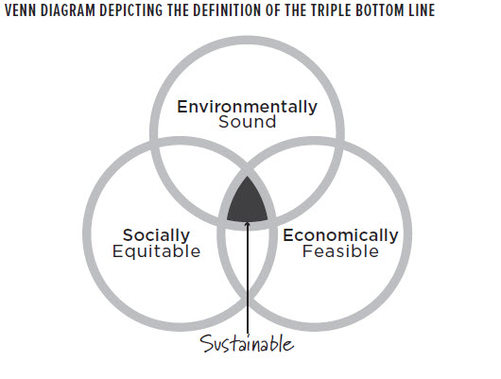
Source: Sustainable Thinking: Ensuring Your Library’s Future in an Uncertain World [ALA Editions, 2018]
This framework aligns with the United Nations 2030 Agenda for Sustainable Development, an inclusive, integrated framework of 17 Sustainable Development Goals (SDGs) that span economic, environmental and social development.
Themes
Through the work of this task force three themes have emerged that guide our thinking about the work to be done:

Theme #1: The Association and Libraries as Inspiration & Catalyst
The Association and Libraries serve as inspiration and catalysts for new ideas, practices, and programs that can transform our communities through leadership, education advocacy, and innovation.
- Lead the Way
  - Model: sustainable/resilient/regenerative facility design; sustainable building operations & grounds; equity, diversity and inclusion through internal operational practices (e.g. recruitment, hiring, benefits);
  - Educate: provision of proactive education/collections/programs on topics related to the Triple Bottom Line (environment, economics, social equity);
  - Advocate: policy development; grassroots organizing; and
  - Innovate: creation of tools, technologies and programs to help other industries operate sustainably; facilitate their community’s sharing economy
Theme #2: The Association and Libraries as Conveners & Connectors
The Association and Libraries have an important role as conveners and connectors of individuals, groups and initiatives.
- Activate Communities
  - Collaboratively Identify Shared Solutions: moving from debate to dialogue to deliberation (Libraries Transform)
  - Life, Liberty & the Pursuit of Happiness: focus on community happiness and self-sufficiency
  - Visionary Partnerships: seek out partnerships that will result in collective impact teams

Theme #3: The Association and Libraries Contribute to Community Resilience
The Association and Libraries contribute to community resilience by their presence, engagement, and commitment to a better future.
- At the Table: Active participation in resiliency/disaster preparedness planning/recovery efforts for libraries and communities;
- Social Cohesion: Focus on creating a community in which people respect, understand and empathize with one another.
Recommendations: Translating Vision into Action
The work that needs to be done must be done in a deliberate order to build a strong foundation for long-lasting change in an arena as large as the world of libraries. “Sustainability” is not an end point but a mindset, a lens through which operational and outreach decisions should be made. To that end the recommendations below are organized in a “building block” approach. Actions are organized to build on one another – from building blocks to capstone events – these recommendations are designed to lead to transformational change in our profession, association and libraries throughout our world. This means bringing people along with us rather than acting in isolation. There is emphasis on education for stakeholders within the organization to inspire widespread understanding and adoption of this mindset. This is critical to the long-term success of this effort.
- How the Association may provide leadership and serve as a model for sustainability practices more broadly in the profession:
 | Action | Delegated to:
1.1 | Adopt sustainability as a core value of the profession; tie existing Core Values of Librarianship to the Resolution on the Importance of Sustainable Libraries | Executive Board/Council
1.2 | Formation of a Sustainability Implementation Team to assist the Executive Board in carrying out the recommendations in this white paper | Executive Board
1.3 | Search Committee for the new ALA Director should work to prioritize the assessment of candidates’ understanding of, and commitment to sustainability issues, in the work of the association | Search Committee
1.4 | Deliberate action to increase and report on socially responsible investments | Council
1.5 | ALA Policy Corps: Advocacy, Legislation, and Issues - key policy issues should encompass sustainability/community resilience issues | ALA Washington Office
1.6 | Assessment and study of Conference Planning across the organization | Conference Services
1.7 | Provision of a “Green Events” checklist to assist Divisions and other groups within the association holding in-person events | Conference Services
1.8 | Orientation to ALA’s commitment to sustainability for the new ALA Executive Director | Transition Team
1.9 | Orientation to ALA’s commitment to sustainability for all future ALA Presidents | Executive Board
1.10 | Orientation for new Council members should include an introduction to the Resolution on the Importance of Sustainable Libraries and this white paper to inform future decision making | Council Orientation Committee
1.11 | Outreach to each Division to brief them on our progress on this topic; encourage the adoption of a Resolution on the Importance of Sustainable Libraries; and development of continuing education/professional development related to sustainability | Executive Director
1.12 | Outreach to each Chapter to brief them on our progress on this topic; encourage the adoption of a Resolution on the Importance of Sustainable Libraries; and development of continuing education/professional development related to sustainability | Chapter Relations Office
1.13 | Orientation and Education for ALA staff (including Washington Office staff) on the topic of sustainability | Executive Director
1.14 | Complete Chicago’s Green Office Space Challenge (this will address dozens of small things like purchasing, energy conservation, etc. in the physical ALA office) | Executive Director
1.15 | ALA staff job descriptions and performance appraisals should include a tie into the Resolution on the Importance of Sustainable Libraries | Executive Director
1.16 | Work to ensure publications, ALA Editions imprints and items offered in ALA Store are sustainably sourced | ALA Staff
1.17 | Create incentive/recognition/award program for exhibit hall vendors to inspire sustainable practices that would help to highlight best practices | Conference Committee
1.18 | Begin using GRI Reporting Standards to communicate impact of sustainability decisions to the ALA membership and beyond | Executive Director
1.19 | Convene ALA Community Conversations to continue to identify opportunities to lead on the topic of sustainability | Executive Board
1.20 | Seek alliances with other national associations working towards a more resilient future | Executive Director
1.21 | Complete the Red Cross Ready Rating Program | Executive Director & ALA Staff
1.22 | Research agenda that ties library services with social cohesion, community resiliency | ALA Research & Statistics Committee
1.23 | Leverage ALA’s leadership on the topic of sustainability as a membership recruitment tool | ALA Membership Committee
1.24 | National press releases related to the role libraries’ play in creating sustainable communities and building community resilience | Public Awareness Office

2. How the Association may provide leadership in the adoption of sustainability practices in libraries:

 | Action | Delegated to:
2.1 | Partner with the New York Library Association to nationally offer a Sustainable Library Certification Program similar to the New York Library Association’s program | Executive Director
2.2 | Publication of “Sustainable Library” Case Studies by library type through ALA Editions | Publishing Committee/ALA Editions
2.3 | American Libraries column on sustainability | American Libraries Editorial Staff
2.4 | Public Libraries column on sustainability | Public Libraries Editorial Staff
2.5 | College & Research Libraries News column on sustainability | College & Research Libraries News Editorial Staff
2.6 | ProgrammingLibrarian.org focus on topics related to sustainability/Triple Bottom Line so exemplars are easy to locate | Public Programs Office
2.7 | Technical and promotional support for the Sustainability Round Table in their work to provide a clearinghouse of 1) sample policies related to operating a more sustainable library (e.g. building operations, human resources, investment) and 2) speakers bureau of people in our profession with expertise in triple bottom line library science and 3) related resources | ALA Staff
2.8 | Create new Project Outcome evaluation tool to measure library impact on social cohesion | PLA Project Outcome
2.9 | Engage “big name” speakers on the topic of sustainability for upcoming conferences. | Board President & Conference Committee
2.10 | Sustainability track of programming at conferences | Conference Committee
2.11 | Ensure professional development opportunities are developed to address core skill development for “sustainable thinking.” | Conference Committee, Divisions & Round Tables
2.12 | Ensure facility awards embed a criteria of sustainable design (e.g. AIA/ALA; ALA/IIDA) | LLAMA Building & Equipment Community of Practice
2.13 | Seed grants to libraries seeking to innovate in ways that will advance the professions understanding of the topic | ALA Divisions & State Chapters
2.14 | Mandate the inclusion of related topics in library school curriculum (e.g. Sustainability/Triple Bottom Line/Collective Impact/Resiliency) | ALA Committee on Accreditation
2.15 | Inspire a vendor to fund the establishment of a Sustainable Library of the Year Award to highlight efforts of a library or chapter that has gone above and beyond to contribute to sustainability in the community or the profession | Executive Board

3. How libraries may provide leadership and serve as a model for sustainability in the communities they serve:
 | Action | Delegated to:
3.1 | Long-range planning should utilize Libraries Transforming Communities resources such as Community Conversations to solicit community information from which to design program and service responses and encourage new partnerships. | Library Board & Administration
3.2 | Adoption of sustainability as a core value in their strategic plan | Library Board & Administration
3.3 | Eco-literacy education for all staff | Library Administration
3.4 | Cultural competency education for all staff | Library Administration
3.5 | Economic Development Basics education for all staff | Library Administration
3.6 | Innovation in programming directly related to the Triple Bottom Line (see footnotes for examples) | Library Director & Staff
3.7 | Participation in local disaster preparedness planning | Library Director & Staff
3.8 | Embed a commitment to sustainability in all employee job descriptions and performance appraisals | Library Director & Department Heads
3.9 | Pursue Sustainable Library Certification through ALA | Library Director
3.10 | Participate in the Red Cross Ready Rating Program | Library Director & Staff
3.11 | Discordant Action Emergency Planning included in disaster/business continuity planning | Library Director & Library Board
3.12 | All new construction should achieve either LEED, Green Globes or Living Building Challenge certification. Library facilities should be used as an educational tool to help citizens learn about passive, sustainable, resilient design choices the library has made | Library Board & Administration
3.13 | For libraries serving populations of over 1 million: create position of “Sustainability Officer” to ensure large projects have oversight/expertise, seek relevant partnerships and serve as an ambassador that can liaison with the sustainability officers of the municipality and school district | Library Board & Director

Conclusion
The members of the task force would like to thank the Executive Board for their vision. There is no more important issue in our time than building on the strengths of the library community for the betterment of our world.

In consultations with ALA Executive Director Mary Ghikas and ALA President Jim Neal, the task force recommends that a short-term working group be maintained to assist the Executive Director and Executive Board as they consider the task force’s recommendations and develop and implementation plan.

We applaud the Executive Board for embracing this opportunity to be the change the world needs today and to build on the momentum of the sustainability movement in our profession. It will serve the association well, in the opinion of this task force.

Submitted by:
Rebekkah Smith Aldrich, Mid-Hudson Library System, Co-Chair
Rene Tanner, Arizona State University, Co-Chair
Monika Antonelli, Minnesota State University, Mankato
Sara Dallas, Southern Adirondack Library System
Adrian K. Ho, University of Kentucky Libraries
Traci Engel Lesneski, MSR
Margaret Woodruff, Charlotte Library
Christian Zabriskie, Urban Libraries Unite/Yonkers Public Library

Appendix
Appendix 1 | Resolution on the Importance of Sustainable Libraries
2014-2015 ALA CD#36_62815_FINAL 2015 ALA Annual Conference
RESOLUTION ON THE IMPORTANCE OF SUSTAINABLE LIBRARIES

Whereas our communities are faced with economic, environmental and societal changes that are of great concern to our quality of life;

Whereas libraries are uniquely positioned and essential to build the capacity of the communities they serve to become sustainable, resilient and regenerative;

Whereas library leaders, and those who inspire future library leaders, have a mandate to ensure future access to economical library services;

Whereas libraries that demonstrate good stewardship of the resources entrusted to them can build community support that leads to sustainable funding;

Whereas the people who work in our libraries and those who access services in our facilities deserve a healthy environment in which to do so;
Whereas the Intergovernmental Panel on Climate Change (IPCC) has determined that: “Human influence on the climate system is clear… Recent climate changes have had widespread impacts on human and natural systems”^{[1]};
Whereas the American Library Association has acknowledged in its 2015 Strategic Plan that “Libraries are widely recognized as key players in economic development, in building strong and vibrant communities, and in sustaining a strong democracy" and launched the ALA Center for Civic Life (CCL) in 2010 in conjunction with the Kettering Foundation to promote community engagement and foster public deliberation through libraries; and

Whereas libraries that demonstrate leadership in making sustainable decisions that positively address climate change, respect and use natural resources, and create healthy indoor and outdoor environments will stabilize and reduce their long-term energy costs, help build more sustainable communities, and thereby increase community support for the library; now, therefore, be it

Resolved, that the American Library Association (ALA), on behalf of its members:
- recognizes the important and unique role libraries play in wider community conversations about resiliency, climate change, and a sustainable future and begins a new era of thinking sustainably in order to consider the economic, environmental and socially equitable viability of choices made on behalf of the association;
- enthusiastically encourages activities by itself, its membership, library schools and state associations to be proactive in their application of sustainable thinking in the areas of their facilities, operations, policy, technology, programming, partnerships and library school curricula; and
- directs the ALA Executive Director to pursue sustainable choices when planning conferences and meetings and to actively promote best practices of sustainability through ALA publications, research and educational opportunities to reach our shared goal of vital, visible and viable libraries for the future.

Adopted by the Council of the American Library Association Sunday, June 28, 2015, in San Francisco, California

Keith Michael Fiels
Executive Director and Secretary of the ALA Council
[1] Intergovernmental Panel on Climate Change (IPCC), 2014: Climate Change 2014: Synthesis Report. Contribution of Working Groups I, II and III to the Fifth Assessment Report of the Intergovernmental Panel on Climate Change [Core Writing Team, R.K. Pachauri and L.A. Meyer (eds.)]. IPCC, Geneva, Switzerland, 151 pp.

Appendix 2 | Committee Charge
The Special ALA Task Force on Sustainability has been charged to develop a white paper that describes areas of focus and recommendations for the ALA Executive Board to increase the adoption and implementation of sustainable practices by the Association, the profession, libraries and the communities they serve. (The ALA Executive Board is asking for a final report by the 2018 New Orleans conference.) TF discussion should include the following:
  - How the Association may provide leadership and serve as a model for sustainability practices more broadly in the profession;
  - How the Association may provide leadership in the adoption of sustainability practices in libraries; and,
  - How libraries may provide leadership and serve as a model for sustainability in the communities they serve.

Appendix 3 | Glossary
- Benchmarks: Measurements developed that provide a positive framework for how an organization or project can best achieve its stated goals. Within the context of sustainability, this may include measurable guidelines that related to governance and policy, information technology, facilities, waste, procurement, community, collections, staff, finance and innovation.
- Community: A social group with a common goal, locality, interest or other cultural characteristics. Within the context of sustainability, this relates to the patrons, staff, trustees, friends of a library and those living and/or working within the area served by the library, such as a town, city or county school, college, or company.
- Library Core Values: An agreed-upon set of concepts that all activities within the institution should support. They are access, adaptability, community, democracy, education and literacy, intellectual freedom, social justice and financial stewardship.
- Regenerative: To bring new, energetic life; revive.
- Renewable Energy: Generally refers to electricity supplied from renewable energy sources, such as wind and solar power, geothermal, hydropower, and various forms of biomass. These energy sources are considered renewable sources because their fuel sources are continuously replenished.
- Resilient: To bounce back after disruption.
- Return on Investment (ROI): An evaluation of the benefit of undertaking an activity versus its cost. This measurement is often used to market library services to voters. For a relatively love investment on the part of each taxpayer, the population served by a library reaps much greater rewards than if the individual paid that same amount for direct services.
- Sphere of Influence: Referring to those people within an organization who set the tone for others. Once those individuals agree to sustainable thinking, it will be much easier to bring others along.
- Stakeholders: Individuals or organization that have a vested interest in maintaining the longevity of a library and its community. There are five stakeholder groups: library patrons, co-creators (library staff and administrators), the community, investors (taxpayers, Trustees, Friends), and Earth systems.
- Sustainability Initiative: A movement to get libraries to make decisions that are in line with their community’s core values, economically feasible, and environmentally sound to ensure that libraries and their communities remain vital, visible, and viable. The Sustainability Initiative is developing tools for all libraries to use so they and the communities they serve can make decisions that ensure those entities are sustainable, resilient and regenerative, and practice Whole Systems Thinking. The Initiative is comprised of five working groups: Agents of Change, Benchmarks, Environmental Scan, Making the Case, and Roadmap.
- Sustainable: The capacity to endure.
- Sustainable Thinking: Sustainable Thinking aligns a library’s core values and resources with the local and global community’s right to endure, to bounce back form disruption and to thrive by bringing new and energetic life to the community through choices made in all areas of operations and outreach.
- Triple Bottom Line: A concept that is best depicted by the Venn diagram in the report. To be truly sustainable, an organization must embody practices that are environmentally sound AND economically feasible AND socially equitable.
- Whole Systems Thinking: A process of understanding how thinking/parts/systems behave and interact with their environments and influence each other.

Source: Excerpted from the “Glossary of Terms,” New York Library Association Sustainability Initiative, https://bit.ly/2tbJr91

Appendix 4 | Survey Report
A “Perceptions Survey” was administered by the Task Force among the ALA membership. This survey was promoted via an ALA Press Release; American Libraries Direct; Councilors listserv; and through various communication channels of the Public Library Association, the Association of College & Research Libraries and the Sustainability Round Table. In addition, notice of the survey was sent to the leadership of Association of School Librarians (AASL), Library Collections & Technical Services (ALCTS), Association for Library Service to Children (ALSC), Association of Specialized & Cooperative Library Agencies (ASCLA), Library & Information Technology Association (LITA), Leadership & Management Association (LLAMA), Reference & User Services Association (RUSA), United for Libraries, and Young Adult Library Services Association (YALSA). Task Force members also engaged in a Facebook campaign to help spread the word about the availability of the survey.

The survey was administered using SurveyMonkey, an online survey tool. Identifying information was not collected. Respondents self-selected themselves to respond to the survey. No question on the survey was required in order to advance to the other questions.
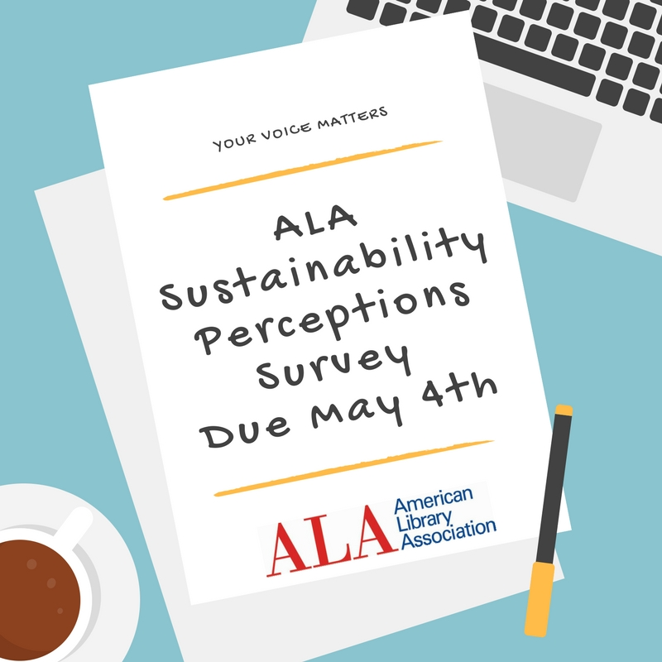
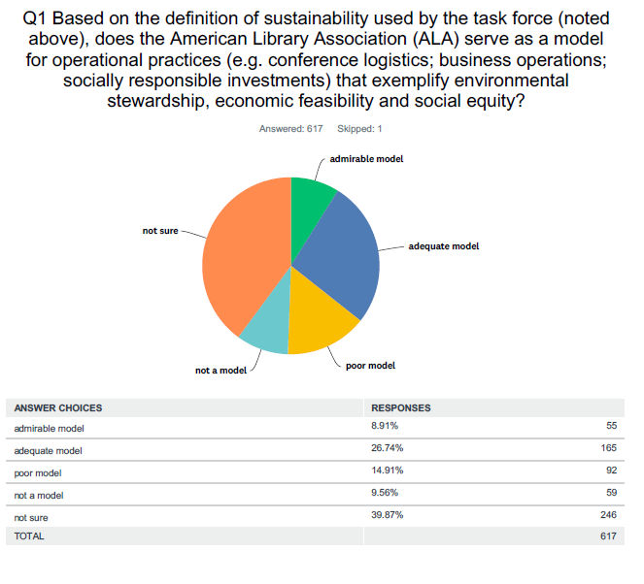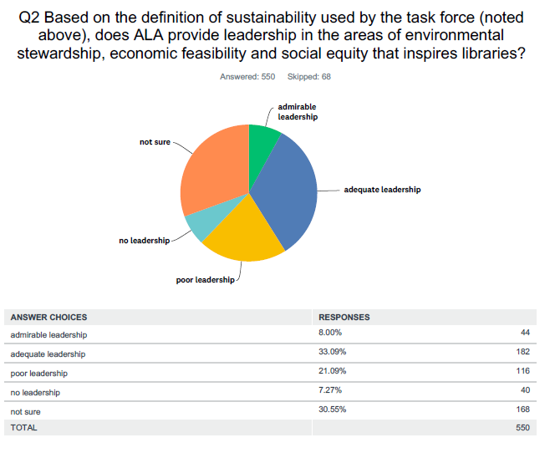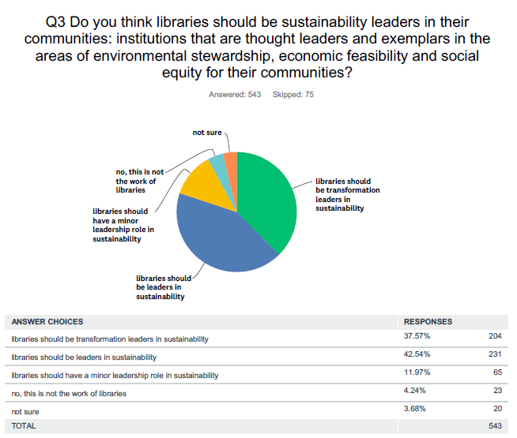

The fourth question solicited examples of libraries that provide leadership and serve as a model for sustainability for those they serve. We received responses from 196 survey participants. Information provided also served to inform many of the recommendations contained in this report.

Appendix 5 | Online Forums
The Task Force hosted a series of online forums in April to seek input from the ALA community. Three forums were targeted at specific audiences while one was open to all who had not had an opportunity to contribute to the discussion. All four sessions were widely promoted in advance through electronic mailing lists and ALA Divisions’ online communication channels.
Each forum was facilitated by two members of the Task Force using Adobe Connect. Attendance at each forum was capped at 100. The facilitators posed four guiding questions and the participants had 10 minutes to respond to each by typing in the chat box. The four questions were:
- What does it look like if libraries are successful in helping create sustainable, resilient, regenerative communities?
- What needs to happen, that is not already happening, to support the American Library Association to realize this vision?
- What needs to happen, that is not already happening, to support our profession to realize this vision?
- What needs to happen, that is not already happening to support libraries to realize this vision?

While the discussion revolved around the questions, the participants also brought up related topics and bounced ideas off each other. The forums were recorded and the forum transcripts provided critical guidance for the Task Force report. Information about the forums is as follows:
Date | Target Audience | Link to Recording | Link to Transcript
April 16 | Sustainability Round Table members | http://ala.adobeconnect.com/p3fexeibcwiu/ | https://docs.google.com/document/d/1n6xIa51BrpZdlFRb6iWmkqTs0KtqN6kUL7IEMGn3a5E/edit
April 23 | Academic library community | http://ala.adobeconnect.com/pamctofj4r43/ | https://docs.google.com/document/d/1DZcLQVbV23AiH3Wqb_P2QYsv5FA9e4L2hO7OPiOREC4/edit
April 26 | Public library community | http://ala.adobeconnect.com/ppyh5tpuphng/ | https://docs.google.com/document/d/1f9FbXyCCJ2I3dzz-C--fkBBGLkvdSvzPmN_aTL4CWQU/edit
April 30 | Open session | http://ala.adobeconnect.com/p5kyds4kgtxq/ | https://docs.google.com/document/d/1yTqp0RxQWY2RFwJ-KS2SwQTyEWbuR3gE4gLNv6BGJKQ/edit

Appendix 6 | UN Sustainable Development Goals
The 17 sustainable development goals (SDGs) to transform our world:
GOAL 1: No Poverty
GOAL 2: Zero Hunger
GOAL 3: Good Health and Well-being
GOAL 4: Quality Education
GOAL 5: Gender Equality
GOAL 6: Clean Water and Sanitation
GOAL 7: Affordable and Clean Energy
GOAL 8: Decent Work and Economic Growth
GOAL 9: Industry, Innovation and Infrastructure
GOAL 10: Reduced Inequality
GOAL 11: Sustainable Cities and Communities
GOAL 12: Responsible Consumption and Production
GOAL 13: Climate Action
GOAL 14: Life Below Water
GOAL 15: Life on Land
GOAL 16: Peace and Justice Strong Institutions
GOAL 17: Partnerships to achieve the Goal

Source: https://www.un.org/development/desa/disabilities/envision2030.html

Appendix 7 | Further Reading/Bibliography
This “Recommended Reading List” was developed for and by the members of the ALA Special Task Force on Sustainability to inform their work in October 2017.
  - Resolution on the Importance of Sustainable Libraries
  - UN Sustainable Development Goals
  - Libraries, Development and the UN 2030 Agenda, IFLA
  - American Libraries web series on Sustainability
    - Libraries and Sustainable Thinking, Rebekkah Smith Aldrich
    - Sustainability’s Community of Practice, Beth Filar Williams & Bonnie Smith
    - Sustainability on the Other Side of the Stacks, Amy Brunvand
    - Strengthening the Voice for Sustainability, Kellie Sparks
    - Triple Bottom Line Sustainability, Gary Shaffer
    - Sustainability in Public Libraries, Arlene Hopkins & Stephen Maack
    - Degrowth is Coming, Edgardo Civallero
  - Library Journal column on Sustainability
    - The Capacity to Endure - May, 2016
    - Local Supports Local - July, 2016
    - Each Choice Tells Our Story | Designing the Future - October, 2016
    - Deliberate Resilience - December, 2016
    - Arming the Ramparts - February, 2017
    - Subversive Librarians - April, 2017
    - Don’t Let This Moment Pass You By, July 2017

  - Partners for the Future: Public Libraries & Local Government Creating Sustainable Futures [Urban Libraries Council, 2010]
  - Rising to the Challenge: Re-Envisioning Public Libraries, A report of the Aspen Institute Dialogue on Public Libraries by Amy K. Garmer
  - The Library as a Refuge Issue [JLAMS]

  - American College & University Presidents' Climate Commitment
  - Small and Rural Libraries
Rural Library Sustainability Project Overview
Rural Library Sustainability Program

  - The Library’s Role in Sustainability

  - Bright Ideas for Sustainability at Harvard Library
  - Green Purchases Policy

  - New York Library Association’s Sustainability Initiative
    - Glossary of Terms
    - White Paper
    - Sustainability Spotlights
    - Road Map to Sustainability

Deep Dives:
  - Sustainable Library Development - Peace Corps (focus on a small section)
  - A Step-by-step guide to turning outward to your community http://www.ala.org/tools/librariestransform/libraries-transforming-communities
  - The Transition Movement http://www.transitionus.org/about-us
    - 7 Guiding Principles http://www.transitionus.org/initiatives/7-principles
    - The 7 Buts http://transitionus.org/initiatives/7-buts
  - The Happiness Report: http://worldhappiness.report/
  - Pages 26-29: Climate Change 2014: Impacts, Adaptation, and Vulnerability http://www.ipcc.ch/pdf/assessment-report/ar5/wg2/ar5_wgII_spm_en.pdf
  - P.M. Forni, Choosing Civility: The Twenty-Five Rules of Considerate Conduct, New York, St. Martin's Press, 2002

http://www.ala.org/news/state-americas-libraries-report-2018
Sustainable Thinking: Ensuring Your Library’s Future in an Uncertain World by Rebekkah Smith Aldrich, ALA Editions, 2018
ALA Mission Statement: http://www.ala.org/aboutala/
ALA Core Values of Librarianship: http://www.ala.org/advocacy/intfreedom/corevalues
ALA Strategic Direction: http://www.ala.org/aboutala/sites/ala.org.aboutala/files/content/governance/StrategicPlan/Strategic%20Directions%202017_Update.pdf
http://www.ala.org/news/press-releases/2015/07/ala-council-passes-resolution-sustainable-libraries
https://sustainabledevelopment.un.org/sdgs
ROI study of in-person vs. virtual conferences that uses the Triple Bottom Line (economics, environmental stewardship and social equity) to assess the strengths of each option. The task force sees great value in face-to-face meetings and is not advocating for the elimination of in-person conferences. However, there does seem to be a need for data-influenced decision making regarding investments in virtual conferencing technology and in-person carbon offset opportunities.
Conference planning should reflect commitment to sustainable practices – attitude of continuous improvement in this area. Resource: http://www.gmicglobal.org/ - Operationally, for example: - Future venue RFPs should prioritize sustainable practices - “Green Registration” option (print program is optional and people can let you know up front; returnable name tags) - Goal: zero waste event - Vendor guidelines to minimize waste - Carbon offset opportunity (e.g. https://www.cooleffect.org/content/news/aall) - Day of Service in the community - Wellness activities for conference attendees - PR about the choices ALA makes; hashtag to track
http://greenpsf.com/go/community/index/chicago
https://www.globalreporting.org
e.g. US Green Building Council, Union of Concerned Scientists, 350.org, The Transition Town Movement, Association for the Advancement of Sustainability in Higher Education
https://www.readyrating.org/The-Red-Cross-Ready-Rating-Program
https://bit.ly/2A7Xbr5
This task force has adopted the “triple bottom line” framework of sustainability to guide our work: To be truly sustainable, an organization or community must embody practices that are environmentally sound AND economically feasible AND socially equitable.
Suggestions include: Charles Montgomery, William McDonough, Majora Carter, Van Jones, Bill Reed, Bill McKibbon, Xiuhtezcatl Martinez, Sylvia Earle; https://www.ucsusa.org/about/expert-search#.WwzG8UgvwmI
For example, pre-conference session on Sustainable Thinking and/or Sustainable Thinking Boot Camp which would cover topics such as: - Change Management - Facilitation - Ecological Literacy - Collective Impact basics - Outcome-based measurement - Sustainable facility operation and design - Project Management - Archives/Local History/Oral Histories - Storytelling as an Advocacy Tool - How to conduct a cost-benefit analysis - Financial planning (e.g. how to reallocate funds to underwrite new initiatives)
Development of library school curriculum on the topic of sustainability should be crafted in consultation with other schools at their institution (schools of business, architecture, etc. who are already developing curriculum in this area)
Examples of programming related to the Triple Bottom Line could include Repair Cafes; The Human Library; self-sufficiency programming (coding, homesteading skills, makerspaces); local and oral history preservation; block parties; financial literacy; eco-literacy; disaster preparedness
Related resources: https://www2.archivists.org/initiatives/mayday-saving-our-archives/ideas-for-mayday-activities; https://www.ready.gov/citizen-corps
This program, if modeled on the New York Library Association’s program, would address a comprehensive list of issues related to policy making; organizational commitment; partnerships and community involvement; social equity and resiliency; financial sustainability; collections; energy and water usage; materials management; transportation; and land use.
https://www.readyrating.org/The-Red-Cross-Ready-Rating-Program

