2017-2018 ALA Memorial #10_71618_FINAL
2018 ALA Annual Conference

This memorial resolution was adopted by the ALA Council on
Tuesday, June 26, 2018

A Memorial Resolution Honoring Mary Lynette Larsgaard

Whereas, the library community and the Association for Library Collections and Technical Services (ALCTS) lost a valued leader on July 18, 2017, with the death of Mary Lynette Larsgaard;
Whereas, Mary Larsgaard dedicated her 40-year career to map librarianship, specializing in map cataloging;
Whereas, she served as Assistant Head and Head of the Map and Imagery Laboratory at the Davidson Library, University of California, Santa Barbara from 1988-2009;
Whereas, she served ALCTS and its Cataloging and Metadata Management Section (CaMMS) in many capacities, including several years as a member and chair of the Committee on Cataloging: Description and Access (CC:DA);
Whereas, she co-founded an international research journal that continues to benefit those within and outside the map library community;
Whereas, she shaped the development of map librarianship through her many publications, leadership in national and regional professional organizations, mentoring and training others;
Whereas, her welcoming, friendly, and outgoing personality greatly enhanced the impact and influence of her scholarship, leadership, and service to the profession; and
Whereas, her leadership, vision, grace, warmth, and humor are missed by all who knew and worked with her; now, therefore, be it
Resolved, that the American Library Association (ALA), on behalf of its members:
- honors the life, leadership, and service of our colleague, Mary Lynette Larsgaard, and thanks her for her outstanding contributions to librarianship; and

- extends its deepest sympathy to Mary’s family and friends.

Adopted by the Council of the American Library Association
Tuesday, June 26, 2018, in New Orleans, Louisiana
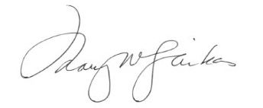
Mary W. Ghikas, Executive Director
and Secretary of the ALA Council

