2017-2018 ALA Memorial #12-71618_ACT
2018 ALA Annual Conference

This memorial resolution was adopted by the ALA Council on
Tuesday, June 26, 2018

A MEMORIAL RESOLUTION HONORING DEG FARRELLY

Whereas, the American Library Association Video Round Table (VRT) and the broader library community lost a dear mentor, colleague and friend on June 9, 2018 with the death of deg farrelly;

Whereas, deg farrelly was a tireless and outspoken advocate for video in libraries;

Whereas, deg farrelly served as a media librarian for over 40 years at Arizona State University and York College of Pennsylvania, enriching the lives of thousands of community members by providing exceptional media resource support and expertise;

Whereas, deg farrelly contributed invaluable foundational scholarship and pioneering streaming licensing models to the field of media librarianship;

Whereas, deg farrelly championed collaborative preservation of VHS collections through his scholarship, national engagement and the Section 108 Video database;

Whereas, deg farrelly generously funded the seed-grant for the National Media Market Academic Libraries Video Trust; and

Whereas, deg farrelly will forever be remembered for his wit, generosity, and enormous heart, now, therefore, be it
Resolved, that the American Library Association Video Round Table (VRT), on behalf of its members:

- recognizes the significant contributions of deg farrelly over the course of his distinguished career and mourns his death, and

- extends its sincerest condolences to his many friends, family and his cherished Lucy.

Adopted by the Council of the American Library Association
Tuesday, June 26, 2018, in New Orleans, Louisiana
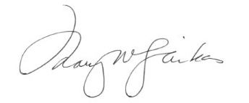
Mary W. Ghikas, Executive Director
and Secretary of the ALA Council

