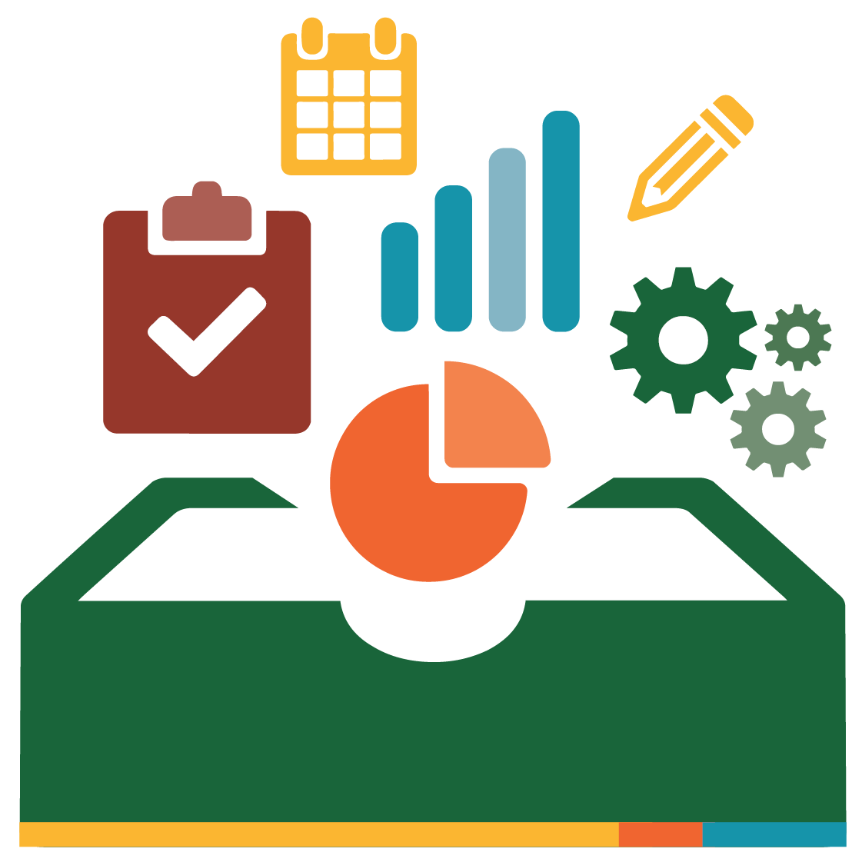
Recording Progress Towards a Library Ecosystem: Template

Please use the template below to record your own progress. Adapt as useful for you.

 | Leadership | Communication | Collaboration | Sustainability
Highly Effective

Reflects a system and structures in place for a thriving and sustainable state-wide ecosystem.
Evolving

Refers to a group establishing practices across organizations towards a state-wide ecosystem.
Beginning

Refers to one or two people initiating work towards a state-wide library ecosystem.
We are here

